DLD PROJECT REPORT

**Group Members**

Muhammad Saad (BSCE22021)

Moiz Ahmad (BSCE22029)

Muhammad Miqdad Ahmad (BSCE22001)

# 

# Abstract

The project is about making a 4-bit multiplier using adders and AND-gates.

# Introduction

The 4-bit multiplier is a device that takes in two binary numbers comprising of four bits each and then gives an answer by multiplying both the numbers in 8-Bit.

# Components Required

1. 4-bit adder IC (74LS83, it is a 16 pin IC).
2. AND-gate IC (DM7408n).
3. Bread board.
4. LEDs.
5. Jumper wires.
6. Push buttons.

# Truth Table

|  |  |  |
| --- | --- | --- |
| 0000 | 0000 | 00000000 |
| 0001 | 0001 | 00000001 |
| 1011 | 1101 | 10001111 |
| 1001 | 1001 | 01010001 |
| 0101 | 1010 | 00110010 |
| 1111 | 1111 | 11100001 |

# Circuit Diagram

# Simulated Diagram

When the circuit is such that all input bits are zero

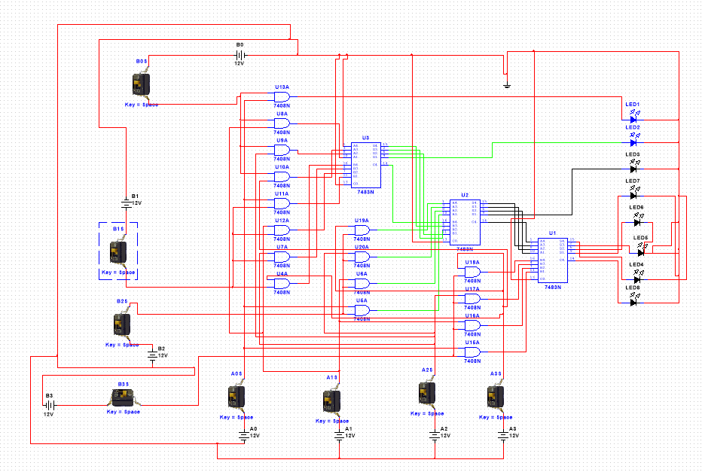

When the circuit is such that all the inputs are ones

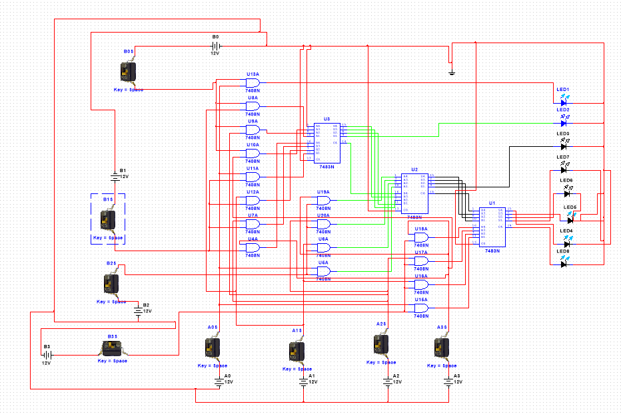

# Working

The circuit multiplies two four-bit binary numbers. For this we multiply the numbers using and gates and 4-bit adders. Each bit is multiplied with each other bit using the and gates and then the products are added as needed.

# Simulated Results

When all input bits are zero, that means we are multiplying two numbers that are 0000 * 0000. This will give us an output of 00000000. That is shown by our simulation result.

When all inputs are 1s. Then that means we are multiplying 1111 * 1111. This makes 15 in decimal. 15 * 15 makes 225. We get an output 11100001.

# Conclusion

The multiplier works perfectly giving exact values.